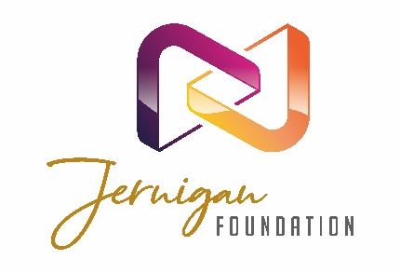
GRANT REPORT FORM

The Jernigan Foundation is pleased to support your organization’s work, and we look forward to hearing about the successes and challenges you’ve had in the past year with the project/program we supported.

Please submit your report by the date requested in our grant agreement letter by filling out the information below and emailing it along with the requisite financial information outlined in Section B to: heather@jerniganfoundation.org. Please limit the narrative part of your grant report to two pages or less.

SECTION A - General Information
Organization: | Primary Contact:
Title of Project/Program: | Phone:
 | Email:
Amount of Grant: | Date of Grant Letter: / /

SECTION B - Financial Report
Please provide specific information on how our grant funds were expended, as well as revenue and expense information for the project/program we funded (or for the whole organization if the grant was not project/program specific). If there are unspent grant funds, please explain.

SECTION C - Narrative Report
- Please summarize in one paragraph the most important outcome from this grant.

- Describe the number of people impacted and how this grant empowered the vulnerable, at-risk, and defenseless toward a flourishing future.

- Please describe how you met the objectives outlined in your grant proposal.

- Did you learn any lessons or face any challenges/barriers with the project/program? If so, how did you handle the challenges, and will the lessons learned inform your future work?

- Please include an anecdotal story that happened because of the project/program our grant funds supported.

- Please include a short summary of how your organization is doing as a whole.

If you have any questions, please contact Heather Tuininga, Executive Director at: heather@jerniganfoundation.org

Please note: grant reports must be current before future grant proposals will be considered.

